

PR2 Report : Cleaning and validation of data

Authors ordered by alphabet:

Daura Hernández Díaz

Xiaowei Cai

URL of GitHub: <https://github.com/likyskyhuuoc/PR2>

|  |  |  |
| --- | --- | --- |
| Contributions | Signatures | |
| Previous research |  |  |
| Writing of the answers |  |  |
| Code development |  |  |

**Contents**

1. Introduction to the context 1

2. Integration and selection of the data 2

3. Data cleaning 4

4. Descriptive data analysis 5

1. Descriptive statistics 5

2. Correlation plot 6

5. Inferential data analysis 7

1. Statistical assumptions 7

2. Kruskal–Wallis one-way analysis of variance 9

3. Lineal regression(OLS) 12

4. Generalized additive model(GAM) 13

5. Regression tree 14

6. Predictive model evaluation and selection 15

SO2 15

NO 16

NO2 17

NOX 18

O3 19

CO 20

PM10 21

PM2.5 22

6. Conclusions 23

7. Code 24

8. Limitations 24

Reference 24

# Introduction to the context

Outdoor air pollution is a major environmental health problem which affects everyone in low, middle, and high income countries.

In 2016, environmental (outdoor) air pollution in urban and rural areas is estimated to cause premature deaths of 4.2 million people worldwide due to exposure to particulate matter (PM2.5) of 2.5 microns or less in diameter, which can lead to cardiovascular disease, respiratory diseases, and cancer (WTO, 2018).

People living in low-income and middle-income countries are burdened with increased outdoor air pollution (91% of the 4.2 million premature deaths) occur in these countries, WHO South-East Asia and the Western Pacific. The region faces the heaviest burden. The latest disease burden estimates show that air pollution can have a major impact on cardiovascular disease and death. There is growing evidence that there is a link between environmental air pollution and cardiovascular disease risk, including research from highly polluted areas(WTO, 2018).

WTO (2018) estimates that in 2016, some 58% of outdoor air pollution-related premature deaths were due to ischaemic heart disease and strokes, while 18% of deaths were due to chronic obstructive pulmonary disease and acute lower respiratory infections respectively, and 6% of deaths were due to the lung cancer.

Even in a developed country like Spain, air pollution is a serious threat to people's health. More than a decades ago, Spanish researchers began to pay a attention to the air pollution problem, and they note that air pollution rate is significantly associated with several health problems, including asthma (Norris et al., 1999) and cardiovascular diseases(Ballester, Tenías, & Pérez-Hoyos, 2001). Unfortunately, until recent years, air pollution is still a serious health threat in this European country, even in the Canary Islands, which is recognised as the one of the cleanest parts in Spain. Previous studies showed that, in the Canary Islands, there is an association between hospitalizations due to heart failure and exposure to particles in the ambient air (Domínguez-Rodríguez et al., 2011) and SO2 pollution (Baldasano, Soret, Guevara, Martínez, & Gassó, 2014; Milford, Marrero, Martin, Bustos, & Querol, 2010).

In this study, we pretend to establish several econometric model to predict the pollution level in the Island of Fuerteventura, one of the seven islands in the Canary Islands. The dataset we used in this study is from a governmental website of the Canary Islands[1]. We selected this data source because it is the public database from the government of the Canary Islands, which provides a variety of air quality indicators through a series of monitor stations across the archipelago.

Moreover, in this research we only focus on the data from a specific monitor station located in Fuerteventura (Casa Palacio-Puerto del Rosario). This monitor station was selected due to two reasons. First, this monitor station has the most comprehensive meteorological and pollution indicators we need for our research across a relatively long time. This weather station has been recording data since 2009, although some indicators were not fully recorded at the beginning. Secondly, the purpose of this study is to establish several predictive models instead of explanatory models. In this case, if we use the data across the seven islands in the archipelago, some exogenous variables may be introduced to the models because of the difference among islands.

Additionally, it is worth mentioning that the crawler which we had created in the PR1 was once again used to simplify the process of obtaining data. When using the crawler, we set up to acquire the daily data from January 2011 to December 2018 in the monitor station of Casa Palacio-Puerto del Rosario with all the meteorological and pollution indicators.

# Integration and selection of the data

According to the mechanism of the governmental website of the Canary Islands, the maximum time span we can download data is 365 days. Therefore, we need to run our crawler multiple times to scrap the data from year 2011 to 2018. After each execution of the crawler, we acquired four original datasets with different indicators, which contain the data within one year. Finally, 32 original datasets were acquired.

The next step is to integrate these original dataset into one unique integrated dataset. To achieve this goal, we applied R programming language.

In terms of the implementation process, firstly, we use cbind() function to integrate the four original datasets of one year to a unique dataset, and we created a new variable named “YEAR” for that later we could track the year of the data. In this phase, we acquired eight datasets named from Fuerteventura_2011 to Fuerteventura_2018. Secondly, the variable names from the original datasets are relatively long, so we create a function called clean_data() to rename these variables because the same task need to be conducted eight times. Thirdly, these eight datasets were integrated into one dataset using rbind() function, and we named it as *Canarydataset*.

13 different air indicators can be found in *Canarydataset*, which are shown in Figure 1. Moreover, date and time are registered in the dataset.

Figure 1 Visualisation of variables in the *Canarydataset*

Here we give the explanations for each variable in the outputs:

**DATE:** Date when the observation is registered. The format is Day-Month-Year.

**HOUR:** Time when the observation is registered. 24-hour system.

**YEAR**: Year when the observation is registered.

MONTH: Month when the observation is registered.

**SO2:** Concentration of SO2 - μg / m³.

**NO:** Concentration of NO - μg / m³.

**NO2:** NO2 - Concentration of NO2 - μg / m³

**NOX:** Concentration of NOX - μg / m³.

**PM10:** Particles in suspension < 10um - μg / m³.

**PM2.5:** Particles in suspension & lt; 2,5um - μg / m³.

**CO:** Concentration of CO - mg / m³.

**O3:** Concentration of O3 - μg / m³.

**VV:** Wind speed (Velocidad del viento)- m / s.

**DD:** Wind direction(Direccion del viento) – Grd.

**TMP:** Average temperature(Temperatura media) - ºC.

**HR:** Relative humidity(Humedad relativa) -%.

**PRB:** Barometric pressure(Presion barometrica) – mb.

# Data cleaning

After having the integrated dataset, we found that in many variables there were NA value. However, we decided to handle this after.

Moreover, we also detected that there existed some outliers in each of the variables, which may finally bias the further data analysis (Osborne, 2010). We used the argument $out in boxplot.stats() function to detect the outliers in each of the variables and replaced by NA values. At this moment, the NA values in the dataset come from two sources: the real missing values in the dataset and the NA value we created to represent the outliers.

Then, we replaced all the NA values from both sources with the mean value of each variable.

# Descriptive data analysis

## Descriptive statistics

We calculated a series of descriptive statistics for each variable in the dataset, including mean standard deviation, skewness, kurtosis, and quartiles. Table 1 summarise the descriptive statistics.

Table 1 Descriptive statistics



Moreover, we generated the histograms for each variables in the dataset to visualisation the statistics mentioned above. These histograms are shown in Figure 2.

Figure Histogram of the variables

## Correlation plot

We also generated a correlation plot to explore the interrelationships among the variables, which is shown on Figure 2.

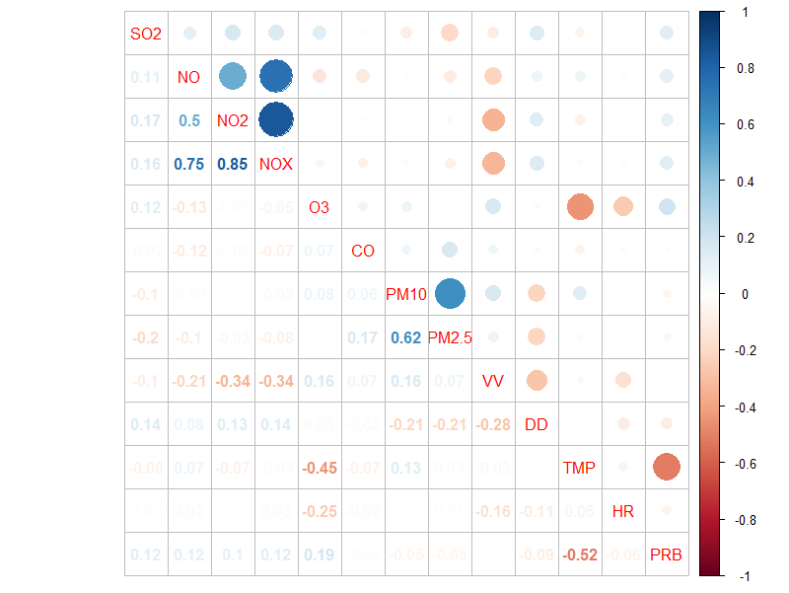

Figure Correlation among variables

# Inferential data analysis

## Statistical assumptions

Before conducting any data analysis, we need to check for statistical assumptions. In this study, we firstly check for the normality and homogeneity of the variance, as these two are the very common statistical assumptions when doing parametric modelling.

Firstly, we used the function mvn() from MVN package to run the Shapiro-Wilk test for each of the variables in the dataset. Table 2 shows the results of Shapiro-Wilk tests, from which we can see that all the variables are not normally distributed.

Table Results of Shapiro-Wilk test

|  |  |  |  |  |
| --- | --- | --- | --- | --- |
| **Test** | **Continuous variable** | **Statistic** | **p value** | **Normality** |
| Shapiro-Wilk | SO2 | 0.8458 | <0.001 | NO |
| Shapiro-Wilk | NO | 0.9556 | <0.001 | NO |
| Shapiro-Wilk | NO2 | 0.969 | <0.001 | NO |
| Shapiro-Wilk | NOX | 0.9754 | <0.001 | NO |
| Shapiro-Wilk | O3 | 0.9959 | <0.001 | NO |
| Shapiro-Wilk | CO | 0.7961 | <0.001 | NO |
| Shapiro-Wilk | PM10 | 0.9629 | <0.001 | NO |
| Shapiro-Wilk | PM2.5 | 0.9174 | <0.001 | NO |
| Shapiro-Wilk | VV | 0.9965 | <0.001 | NO |
| Shapiro-Wilk | DD | 0.6785 | <0.001 | NO |
| Shapiro-Wilk | TMP | 0.9842 | <0.001 | NO |
| Shapiro-Wilk | HR | 0.9907 | <0.001 | NO |
| Shapiro-Wilk | PRB | 0.9882 | <0.001 | NO |

Moreover, we applied leveneTest() function from the car package to conduct Levene's Tests for each variable across the two categorical variables: YEAR and MONTH. The results are summarised in Table 3, which shows that all the variables are not homogeneous when crossing either categorical variable.

Table Results of Levene's Test

|  |  |  |  |  |  |
| --- | --- | --- | --- | --- | --- |
| **Test** | **Continuous variable** | **Categorical variable** | **Statistic** | **p value** | **Homogeneity** |
| Levene's Test | SO2 | YEAR | 79.722 | <0.001 | NO |
| Levene's Test | NO | YEAR | 24.438 | <0.001 | NO |
| Levene's Test | NO2 | YEAR | 12.325 | <0.001 | NO |
| Levene's Test | NOX | YEAR | 10.899 | <0.001 | NO |
| Levene's Test | O3 | YEAR | 8.614 | <0.001 | NO |
| Levene's Test | CO | YEAR | 13.147 | <0.001 | NO |
| Levene's Test | PM10 | YEAR | 2.0417 | <0.001 | NO |
| Levene's Test | PM2.5 | YEAR | 28.735 | <0.001 | NO |
| Levene's Test | VV | YEAR | 8.9392 | <0.001 | NO |
| Levene's Test | DD | YEAR | 78.135 | <0.001 | NO |
| Levene's Test | TMP | YEAR | 11.605 | <0.001 | NO |
| Levene's Test | HR | YEAR | 7.4645 | <0.001 | NO |
| Levene's Test | PRB | YEAR | 29.396 | <0.001 | NO |
| Levene's Test | SO2 | MONTH | 3.676 | <0.001 | NO |
| Levene's Test | NO | MONTH | 3.1918 | <0.001 | NO |
| Levene's Test | NO2 | MONTH | 9.8367 | <0.001 | NO |
| Levene's Test | NOX | MONTH | 4.2942 | <0.001 | NO |
| Levene's Test | O3 | MONTH | 2.4158 | <0.001 | NO |
| Levene's Test | CO | MONTH | 6.9237 | <0.001 | NO |
| Levene's Test | PM10 | MONTH | 3.8309 | <0.001 | NO |
| Levene's Test | PM2.5 | MONTH | 2.4925 | <0.001 | NO |
| Levene's Test | VV | MONTH | 12.358 | <0.001 | NO |
| Levene's Test | DD | MONTH | 6.8889 | <0.001 | NO |
| Levene's Test | TMP | MONTH | 4.0598 | <0.001 | NO |
| Levene's Test | HR | MONTH | 12.707 | <0.001 | NO |
| Levene's Test | PRB | MONTH | 6.6185 | <0.001 | NO |

Due to that our data does not show the normality nor the homogeneity, we decided to apply non-parametric methods instead of parametric methods when analysing the data.

## Kruskal–Wallis one-way analysis of variance

Although the main purpose of this study is to establish econometric models to predict the pollution levels, we also would like to verify whether the pollution indicators are significant different from year 2011 to 2018.

We firstly generated a series of boxplots classified by YEAR and MONTH, which are shown in Figure 4 and Figure 5. From the visualisation, we can easily infer that the mean value is significant different in many cases. For example, the TMP(temperature) is significantly different across the month. However, statistical tests need to be done to confirm our intuition.

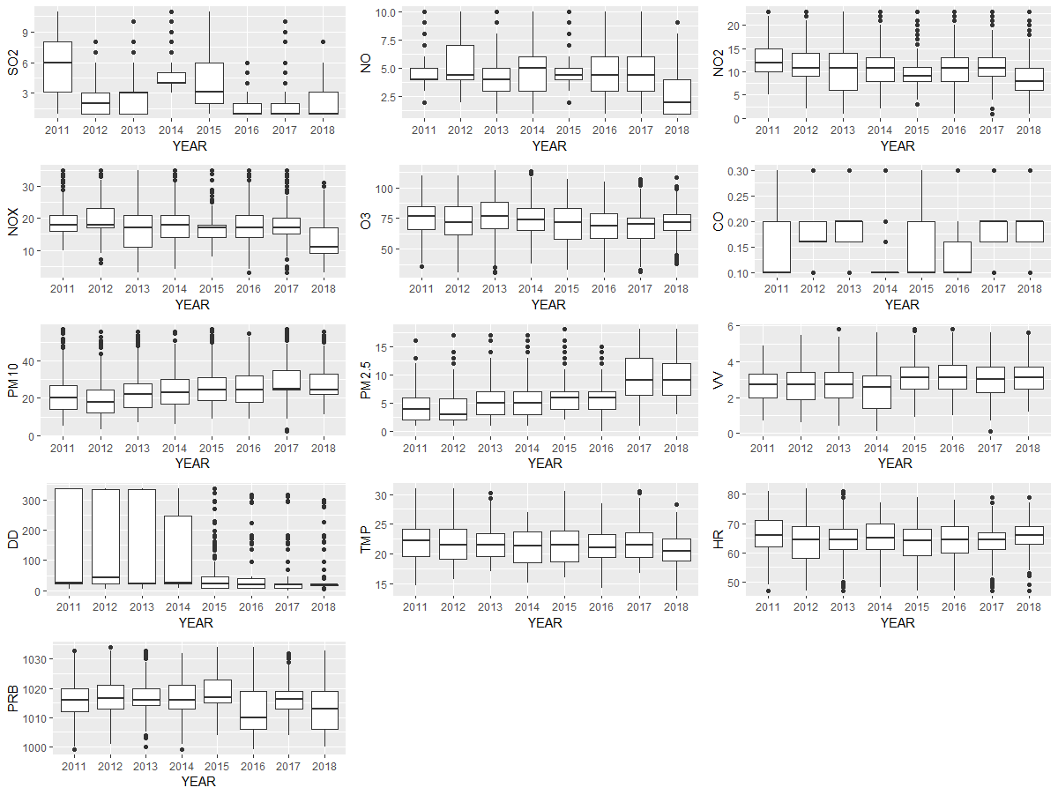

Figure Boxplots by year

Figure Boxplots by month

In the current study, parametric methods like ANOVA cannot be conducted due to the violation of the statistical assumptions(normality and homogeneity). Thus, a non-parametric method, Kruskal–Wallis test, was adopted to verify whether the mean value is equal in each of the categorical variable. Table 4 shows the results of Kruskal–Wallis test, which indicate that all continuous variables are significantly different respect to the mean value among all the categorical groups.

Table Results of Kruskal-Wallis test

|  |  |  |  |  |
| --- | --- | --- | --- | --- |
| **Test** | **Continues variable** | **Categorial variable** | **Statistic** | **p value** |
| Kruskal-Wallis | SO2 | YEAR | 1176.6 | <0.001 |
| Kruskal-Wallis | NO | YEAR | 478 | <0.001 |
| Kruskal-Wallis | NO2 | YEAR | 229.44 | <0.001 |
| Kruskal-Wallis | NOX | YEAR | 369.87 | <0.001 |
| Kruskal-Wallis | O3 | YEAR | 116.38 | <0.001 |
| Kruskal-Wallis | CO | YEAR | 631.74 | <0.001 |
| Kruskal-Wallis | PM10 | YEAR | 288.07 | <0.001 |
| Kruskal-Wallis | PM2.5 | YEAR | 875.5 | <0.001 |
| Kruskal-Wallis | VV | YEAR | 151.66 | <0.001 |
| Kruskal-Wallis | DD | YEAR | 737.22 | <0.001 |
| Kruskal-Wallis | TMP | YEAR | 49.284 | <0.001 |
| Kruskal-Wallis | HR | YEAR | 53.625 | <0.001 |
| Kruskal-Wallis | PRB | YEAR | 195.25 | <0.001 |
| Kruskal-Wallis | SO2 | MONTH | 44.339 | <0.001 |
| Kruskal-Wallis | NO | MONTH | 73.909 | <0.001 |
| Kruskal-Wallis | NO2 | MONTH | 302.1 | <0.001 |
| Kruskal-Wallis | NOX | MONTH | 210.69 | <0.001 |
| Kruskal-Wallis | O3 | MONTH | 765.75 | <0.001 |
| Kruskal-Wallis | CO | MONTH | 100.35 | <0.001 |
| Kruskal-Wallis | PM10 | MONTH | 107.31 | <0.001 |
| Kruskal-Wallis | PM2.5 | MONTH | 77.617 | <0.001 |
| Kruskal-Wallis | VV | MONTH | 476.66 | <0.001 |
| Kruskal-Wallis | DD | MONTH | 75.879 | <0.001 |
| Kruskal-Wallis | TMP | MONTH | 2244.7 | <0.001 |
| Kruskal-Wallis | HR | MONTH | 171.35 | <0.001 |
| Kruskal-Wallis | PRB | MONTH | 1120.2 | <0.001 |

## Lineal regression(OLS)

Although, as we have mentioned before, our data does not demonstrate the normality and homogeneity, which violate the statistical assumptions of many parametric method. However, we firstly try lineal regression as it is the preferred statistical modelling method for numerical variables (Zumel & Mount, 2014). Researchers should always try linear regression first, and only use more complex methods when more complex methods are better than linear regression models (Zumel & Mount, 2014).

We conducted the log transformation for the variables hoping that the statistical assumptions of least squares method can be satisfied. In this phase, eight regression model were established, and the relationship between dependent and independent variables is based on the previous correlation analysis. These models are shown as following:

**Model1:**lm(log(SO2+1) ~ NO+NO2+NOX+O3+PM2.5+VV,data=Canarydataset_training)

**Model2:**m(log(NO+1) ~ NO2+NOX+O3+HR+PRB,data=Canarydataset_training)

**Model3:**m(log(NO2+1) ~ SO2+NO+NOX+O3+HR+PRB,data=Canarydataset_training)

**Model4:**m(log(NOX+1) ~ SO2+NO+NO2+O3+HR+PRB,data=Canarydataset_training)

**Model5:**m(log(O3+1) ~ SO2+NO+NO2+NOX+HR+PRB,data=Canarydataset_training)

**Model6:**m(log(CO+1) ~ NO+NO2+NOX+PM2.5+DD+HR,data=Canarydataset_training)

**Model7:**m(log(PM10+1) ~ NO+PM2.5+DD+TMP+HR+PRB,data=Canarydataset_training)

**Model8:**m(log(PM2.5+1)~ SO2+PM10+VV+DD+TMP,data=Canarydataset_training)

Moreover, we used gvlma() function from the gvlma package (Peña & Slate, 2006) to verify the statistical assumptions of least squares method. However, unfortunately, according to the method of Peña & Slate (2006), all these eight lineal regression models do not satisfy the statistical assumptions, which obliged us to seek for the more complex non-parametric methods to achieve our research goal.

## Generalized additive model(GAM)

As our dataset violate several statistical assumptions that prevented us from using parametric methods, we turned to some non-parametric statistical method and machine leaning algorithm to achieve our goal.

An important statistical development of the last 30 years has been the advance in regression analysis provided by generalized additive models (GAMs) (Guisan, Edwards, Jr, & Hastie, 2002). GAMs are semi-parametric extensions of GLMs , and the only underlying assumption made is that the functions are additive and that the components are smooth. The strength of GAMs is their ability to deal with highly non-linear and non-monotonic relationships between the response and the set of explanatory variables (Guisan et al., 2002).

In the R environment, GAMs can be implemented by using gam() function of mgcv package. Before running the GAM, we randomly separated the dataset into training set(*Canarydataset_training*) and verification set(*Canarydataset_verification*), and in each subset, there are 50% of the total observations. Additionally, set.seed() function was used so that we could replicate the results in the future. These two subsets will also be used in the regression tree analysis, which will be explained in the next section.

The models we specified for GAMs are the same as we did before for lineal regressions, which are shown as following:

**Model1:** s(NO)+s(NO2)+s(NOX)+s(O3)+s(PM2.5)+s(VV),data=Canarydataset_training)

**Model2:**gam(NO ~ s(NO2)+s(NOX)+s(O3)+s(HR)+s(PRB),data=Canarydataset_training)

**Model3:**gam(NO2 ~ (SO2)+s(NO)+s(NOX)+s(O3)+s(HR)+s(PRB),data=Canarydataset_training)

**Model4:**gam(NOX ~ s(SO2)+s(NO)+s(NO2)+s(O3)+s(HR)+s(PRB),data=Canarydataset_training)

**Model5:**gam(O3 ~ s(SO2)+s(NO)+s(NO2)+s(NOX)+s(HR)+s(PRB),data=Canarydataset_training)

**Model6:**gam(CO ~ s(NO)+s(NO2)+s(NOX)+s(PM2.5)+s(DD)+s(HR),data=Canarydataset_training)

**Model7:**gam(PM10 ~ (NO)+s(PM2.5)+s(DD)+s(TMP)+s(HR)+s(PRB),data=Canarydataset_training)

**Model8:**gam(PM2.5 ~ s(SO2)+s(PM10)+s(VV)+s(DD)+s(TMP),data=Canarydataset_training)

Comprehensive results of these GAMs are not going to be displayed here due to space reasons. Instead, we encourage our readers to check the document analysis.html for exhaustive outputs.

## Regression tree

GAM is a powerful statistical tool to analysis our dataset, but it is not the only method. However, if we shift our focus from statistics to machine learning, there may be more options to solve the same problem. Among all the possible machine leaning algorithm, maybe regression tree is more suitable for our study.

The regression tree was introduced as part of the classification regression tree algorithm(CART) in the 1980s (Breiman, Friedman, Olshen, & Stone, 1984). The regression tree does not use a linear regression method, but instead makes predictions based on the average of the cases that arrive at the leaf nodes (Lantz, 2015). In some cases, the fit of some kinds of data is much better than lineal regression model (Lantz, 2015).

In the R environment, regression tree can be implemented by using rpart() function in the rpart package.

The models we specified for regression trees are the same as we did before for lineal regressions, which are shown as following:

**Model1:**rpart(SO2 ~NO+NO2+NOX+O3+PM2.5+VV,data=Canarydataset_training)

**Model2:**rpart(NO ~NO2+NOX+O3+HR+PRB,data=Canarydataset_training)

**Model3:**rpart(NO2 ~SO2+NO+NOX+O3+HR+PRB,data=Canarydataset_training)

**Model4:**rpart(NOX ~SO2+NO+NO2+O3+HR+PRB,data=Canarydataset_training)

**Model5:**rpart(O3 ~SO2+NO+NO2+NOX+HR+PRB,data=Canarydataset_training)

**Model6:**rpart(CO ~NO+NO2+NOX+PM2.5+DD+HR,data=Canarydataset_training)

**Model7:**rpart(PM10 ~NO+PM2.5+DD+TMP+HR+PRB,data=Canarydataset_training)

**Model8:**rpart(PM2.5 ~ SO2+PM10+VV+DD+TMP,data=Canarydataset_training)

Comprehensive results of these regression trees are not going to be displayed here due to space reasons. Instead, we encourage our readers to check the document analysis.html for exhaustive outputs.

## Predictive model evaluation and selection

Now we have eight GAM models and eight regression tree models, and at this moment we would like to know which of the two types of approaches functions better for each of the dependent variables. We used predict() function with our verification set(*Canarydataset_verification*) to evaluate the performance of the established models. In the current study, the evaluation criterion is based on NMSE(Normalised Mean Square Error)[2], and scatter plots helps us to understand the results more intuitively.

## SO2

In the models where SO2 is a dependent variable, the NMSE value for GAM model is 0.8669353 and the NMSE value for regression tree model is 0.9242515. Thus, neither of the two models performs well, although the performance of the GAM model is slightly better. Figure 6 compares the GAM model and the regression tree model.

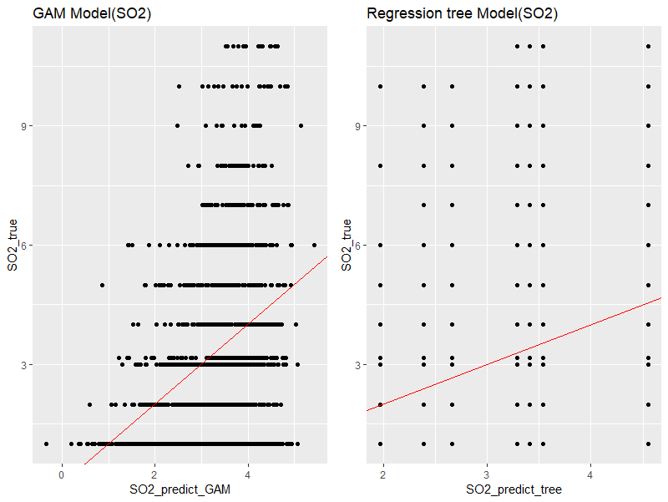

Figure Model evaluation(SO2 as the dependent variable)

## NO

In the models where NO is a dependent variable, the NMSE value for GAM model is 0.2903619 and the NMSE value for regression tree model is 0.32765. Thus, both of the two models perform well, although the performance of the GAM model is slightly better. Figure 7 compares the GAM model and the regression tree model.

Figure Model evaluation(NO as the dependent variable)

## NO2

In the models where NO2 is a dependent variable, the NMSE value for GAM model is 0.1996935 and the NMSE value for regression tree model is 0.270828. Thus, both of the two models perform well, although the performance of the GAM model is slightly better. Figure 8 compares the GAM model and the regression tree model.

Figure Model evaluation(NO2 as the dependent variable)

## NOX

In the models where NOX is a dependent variable, the NMSE value for GAM model is 0.124064 and the NMSE value for regression tree model is 0.2002506. Thus, both of the two models perform well, although the performance of the GAM model is slightly better. Figure 9 compares the GAM model and the regression tree model.

Figure Model evaluation(NOX as the dependent variable)

## O3

In the models where O3 is a dependent variable, the NMSE value for GAM model is 0.8522244 and the NMSE value for regression tree model is 0.8485102. Thus, neither of the two models performs well, although the performance of the tree model is slightly better. Figure 10 compares the GAM model and the regression tree model.

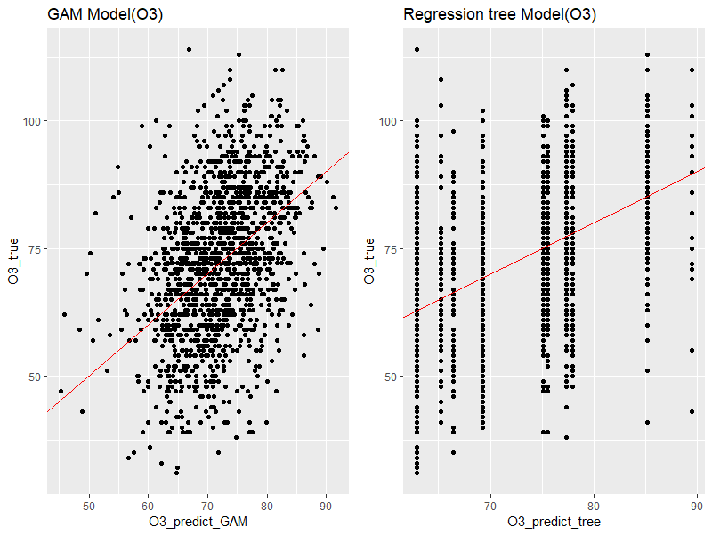

Figure Model evaluation(O3 as the dependent variable)

## CO

In the models where CO is a dependent variable, the NMSE value for GAM model is 0.9556282 and the NMSE value for regression tree model is 0.945722. Thus, neither of the two models performs well, although the performance of the tree model is slightly better. Figure 11 compares the GAM model and the regression tree model.

Figure Model evaluation(CO as the dependent variable)

## PM10

In the models where PM10 is a dependent variable, the NMSE value for GAM model is 0.497423 and the NMSE value for regression tree model is 0.5187397. Thus, neither of the two models perform generally well, although the performance of the GAM model is slightly better. Figure 12 compares the GAM model and the regression tree model.

Figure Model evaluation(PM10 as the dependent variable)

## PM2.5

In the models where SO2 is a dependent variable, the NMSE value for GAM model is 0.5230972 and the NMSE value for regression tree model is 0.5680897. Thus, both of the two models perform generally well, although the performance of the GAM model is slightly better. Figure 12 compares the GAM model and the regression tree model.

Figure Model evaluation(PM2.5 as the dependent variable)

# Conclusions

In this research, we aimed to establish predictive models to forecast the pollution level in Fuerteventura, one of the seven islands in the Canary Islands. To reach this goal, we used the crawler that we had created in the PR1 to acquire the datasets we wanted, and later we used R programming language to integrate, clean, and analyse the data. Several statistical and machine leaning methods were used in this research. Firstly, we conducted descriptive statistical analysis to explore the relationships among the variables. Then, Shapiro-Wilk tests and Levene's tests were conducted to test the normality and homogeneity of the data. Additionally, Kruskal-Wallis tests were conducted to verify whether the mean value of the meteorological and pollution variables were significantly different across the year and month. In terms of the inferential statistic, we transformed dependent variables to run lineal regression models with ordinary least squares estimation. However, even the dependent variables were transformed, these lineal regression models did not meet the statistical assumptions. Due to this reason, Generalized additive model and Regression tree were used in this study as two alternative methods to establish predictive models. As the final step, we compare the fits of model using Normalised Mean Square Error value and visualisation. We found that the models to predict NO, NO2, and NOX were well fitted. The models to predict PM10 and PM2.5 were generally well fitted. Nevertheless, the models to predict SO2, O3, and CO were not well fitted. In conclusion, we partially reached our research goals

# Code

Due to the space and simplicity reasons, the source R code will not be displayed here. In turn, our readers can find the full code as well as the original datasets of this project in GitHub[3]. We highly encourage our readers to check the RMarkdown file to understand the entire implementation process of this project.

# Limitations

Like all investigations, our research is subject to some limitations. Maybe one of the biggest limitation of this study is that the two authors of this study are not specialist in the field of environmental science. As a result, no literature review has been done before conducting the data analysis, which may lead to some errors that are closely related to subject knowledge. Additionally, we tried to avoid interpreting the results of data analysis because the process of interpretation requires a great need of subject knowledge. Finally, all the datasets we used in this study were from a specific monitor station() in Fuerteventura, which may limit the generalisability to the whole island.

# Reference

Baldasano, J. M., Soret, A., Guevara, M., Martínez, F., & Gassó, S. (2014). Integrated assessment of air pollution using observations and modelling in Santa Cruz de Tenerife (Canary Islands). *Science of the Total Environment*. https://doi.org/10.1016/j.scitotenv.2013.12.062

Ballester, F., Tenías, J. M., & Pérez-Hoyos, S. (2001). Air pollution and emergency hospital admissions for cardiovascular diseases in Valencia, Spain. *Journal of Epidemiology and Community Health*. https://doi.org/10.1136/jech.55.1.57

Breiman, L., Friedman, J. H., Olshen, R. A., & Stone, C. J. (1984). *Classification and regression trees* (1st ed.). New York: Routledge. https://doi.org/10.1201/9781315139470

Domínguez-Rodríguez, A., Abreu-Afonso, J., Rodríguez, S., Juárez-Prera, R. A., Arroyo-Ucar, E., Jiménez-Sosa, A., … Avanzas, P. (2011). Comparative Study of Ambient Air Particles in Patients Hospitalized for Heart Failure and Acute Coronary Syndrome. *Revista Española de Cardiología (English Edition)*. https://doi.org/10.1016/j.rec.2010.12.023

Guisan, A., Edwards, T. C., Jr, & Hastie, T. (2002). Generalized linear and generalized additive models in studies of species …. *Ecological Modelling*, *157*. Retrieved from http://linkinghub.elsevier.com/retrieve/pii/S0304380002002041

Lantz, B. (2015). *Machine Learning with R* (2nd ed.). Packt Publishing.

Milford, C., Marrero, C., Martin, C., Bustos, J. J., & Querol, X. (2010). Forecasting the air pollution episode potential in the Canary Islands. *Advances in Science and Research*. https://doi.org/10.5194/asr-2-21-2008

Norris, G., YoungPong, S. N., Koenig, J. Q., Larson, T. V., Sheppard, L., & Stout, J. W. (1999). An association between fine particles and asthma emergency department visits for children in Seattle. *Environmental Health Perspectives*. https://doi.org/10.1289/ehp.99107489

Osborne, J. W. (2010). Data Cleaning Basics: Best Practices in Dealing with Extreme Scores. *Newborn and Infant Nursing Reviews*, *10*(1), 37–43. https://doi.org/10.1053/j.nainr.2009.12.009

Peña, E. A., & Slate, E. H. (2006). Global Validation of Linear Model Assumptions. *Journal of the American Statistical Association*, *101*(473), 341–354. Retrieved from https://amstat.tandfonline.com/doi/abs/10.1198/016214505000000637#.XHRiuIhKjIU

WTO. (2018). Ambient (outdoor) air quality and health. Retrieved from https://www.who.int/news-room/fact-sheets/detail/ambient-(outdoor)-air-quality-and-health

Zumel, N., & Mount, J. (2014). *Practical data science with R* (1st ed.). Manning Publications Co.

1. URL: <http://www.gobiernodecanarias.org/medioambiente/calidaddelaire/datosHistoricos.do>
2. The NMSE (Normalised Mean Square Error) is an estimator of the overall deviations between predicted and measured values. NMSE is a ratio and usually ranges from 0 to 1. If the model performs well, the NMSE value should be significantly less than one. That is to say, the smaller the value of NMSE, the better the performance of the model.
3. URL: <https://github.com/likyskyhuuoc/PR2>